

Submitted by:
Name: Istiak Alam
ID: 05
Batch: 20
Lab report: 06
Date: 26.11.22
Course: CSE LAB
Course Code: 1202
Lab task Topic:
- Rock Paper Scissor Game For Two Users

Submitted to:
Nafisa Tabassum

LECTURER, NDUB

Problem No. 01
Name of the problem:
Write a C program to find the Winner of Rock Paper Scissor Game Among Two Users
Introduction
Implementing program in C is very interesting. To implement the problem given above we should remember the procedure to display outcome. That is, we should consider about the required inputs, the particular process that will be applied upon the input data and the output whether it is desired or not. The given problem gives me an opportunity to have an exercise on the procedure.

Program:
//Rock Paper Scissor Game
#include <stdio.h>
int main()
{
char p1,p2;
printf("\tLets play rock paper scissor.\n\n");
printf("Player 1 select your Choice.\nAmong Rock, Paper, Scissor\n");
printf("Press 'r' for Rock\nPress 'p' for Paper\nPress 's' for Scissor\n");
scanf("%c",&p1);
printf("Player 2 select your Choice");
printf("\nPress 'r' for Rock\nPress 'p' for Paper\nPress 's' for Scissor\n");
scanf(" %c",&p2);
switch(p1)
{
case 'r':
(p2=='r')? printf("Game Draw!!") : (p2=='s')? printf("Player 1 Win...!!") : printf("Player 2 Win...!!");
break;
case 's':
(p2=='s')? printf("Game Draw!!") : (p2=='p')? printf("Player 1 Win...!!") : printf("Player 2 Win...!!");
break;
case 'p':
(p2=='p')? printf("Game Draw!!") : (p2=='r')? printf("Player ! Win...!!") : printf("Player 2 Win...!!");
break;
default :
printf("Game Error");
break;
}
}

Output :
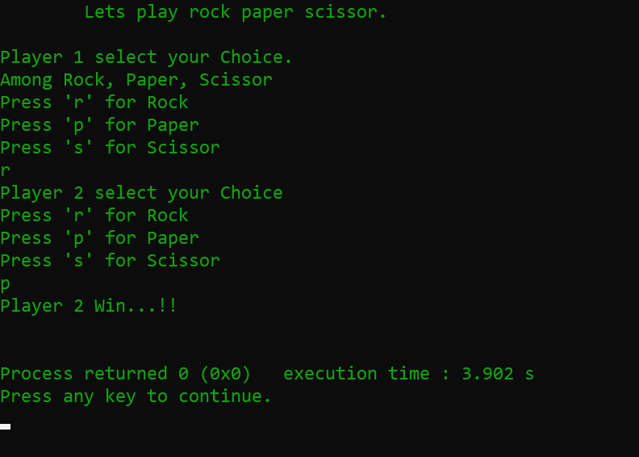

THE END

